INFRAVISION
A Technical Magazine of Civil Engineering Department
Dr. A. D. Shinde Institute of Technology
Academic Year 2025 – 26
(EVEN)

- About DADSIOT

Dr. A. D. Shinde Institute of Technology (DADSIOT) is an establishment of Dinkarrao K. Shinde Smarak trust, Gadhinglaj in the year of 2008.The prime motive of the institute is to inculcate moral values in the students of 21st century even the institute inspires to change rural potential into modern technologies. The institute is approved by AICTE, New Delhi, DTE Mumbai and Govt. of Maharashtra, Affiliated to MSBTE, Mumbai Dr. A. D. Shinde Institute of Technology (DADSIOT) is one of the outcomes of sincere efforts of Adv. Shri Shripatrao Shinde (Ex MLA) His aim is to impart quality education to the students from rural area. Definitely Dr. A. D. Shinde Institute of Technology will contribute in National Development by its engineers.
- Vision of Institute

“To become an excellent technological institute committed to develop a versatile professional to satisfy the needs of industry, society, and the environment.”
- Mission of Institute

1. To provide a quality education to achieve best placements.
2. To build leadership qualities to grow professionally and as entrepreneur.
3. To develop an industry competent engineer.
4. To inculcate a sense of social and environmental responsibilities.

- About Department
The Department of Civil Engineering was established in 2008 and has made remarkable progress over the past 15 years. The department offers a strong Diploma Programme in Civil Engineering, focusing on developing competent and industry-ready civil engineers.
The department is committed to providing quality technical education in core civil engineering areas such as surveying, construction technology, structural engineering, transportation engineering, environmental engineering, and geotechnical engineering. Emphasis is placed on maintaining high academic standards supported by an updated and industry-oriented curriculum.
The primary objective of the curriculum is to impart sound technical knowledge, enhance problem identification and problem-solving skills, and encourage innovation and the adoption of modern construction practices and emerging technologies. The department’s commendable placement record stands as a testimony to its academic excellence and industry relevance.
The department is supported by a team of highly qualified and experienced faculty members who are dedicated to teaching, mentoring, and the overall development of students.
Thank you for sparing your valuable time and visiting the Department of Civil Engineering.
- DEPARTMENT VISION
To become an excellent civil engineering department committed to provide quality education to satisfy the needs of industry and society.

- DEPARTMENT MISSIONS
- To develop an entrepreneurial culture to face the challenges of sustainable development.
- To inculcate habit of innovation to develop the cost-effective methods of construction.
- To inculcate professional ethics to serve the society.

- Program Education Outcome
PEO1 | Emerge as a successful entrepreneur and practicing professional for sustainable construction
PEO2 | Pursue higher education for implementing modern techniques in the field of construction.
PEO3 | Develop professional and ethical attitude for making positive impact on society.

- Program Specific Outcome
PSO1 | Design and Estimation  Design and estimate cost effective structure with quality and safety.
PSO2 | Primary Construction Activity  Conduct surveys, prepare plans, and mark layout required for construction

- Program Outcome
PO1 | Basic and Discipline specific knowledge:  Apply knowledge of basic mathematics, science and engineering fundamentals and engineering specialization to solve the engineering problems.
PO2 | Problem analysis:  Identify and analyse well-defined engineering problems using codified standard methods.
PO3 | Design/ development of solutions:  Design solutions for well-defined technical problems and assist with the design of systems components or processes to meet specified needs.
PO4 | Engineering Tools, Experimentation and Testing:  Apply modern engineering tools and appropriate technique to conduct standard tests and measurements.
PO5 | Engineering practices for society, sustainability and environment:  Apply appropriate technology in context of society, sustainability, environment and ethical practices.
PO6 | Project Management:  Use engineering management principles individually, as a team member or a leader to manage projects and effectively communicate about well-defined engineering activities.
PO7 | Life-long learning:  Ability to analyse individual needs and engage in updating in the context of technological changes.

- Messages
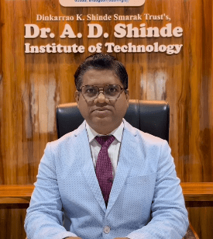 | Dr. A. D. Shinde Institute of Technology is one among reputed technical institutions imparting finest quality education. The evolution of the Institute over the past years has committed to provide professional education with thrust on creativity and innovation.  In DADSIOT, it is believed and practiced that excellence is a continuous process and in pursuit of which the institute has made deep forays into contributing world-renowned technocrats, successful entrepreneurs, competent leaders, innovative scientists and researchers.  I assure the academic, professional and social growth of upcoming engineers at our Institute and wish very all the best to my students for an excellent learning experience at DADSIOT.
Dr. Sanjaykumar M. Ingale,
Principal,
Dinkarrao K. Shinde Smarak Trust’s,
Dr. A. D. Shinde Institute Of Technology

- FROM THE DESK OF HOD

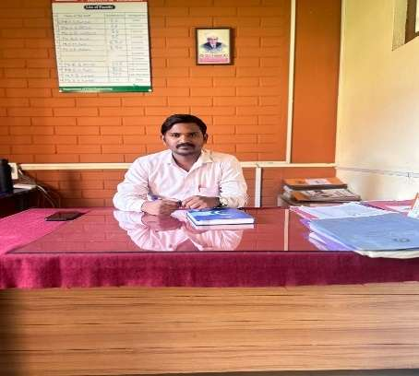
We are delighted to present InfraVision, the Department of Civil Engineering’s official magazine dedicated to bridging academic excellence with the dynamic world of infrastructure and construction. Each issue brings you closer to the latest advancements in civil engineering, insightful industrial visits, expert guest lectures, innovative student projects, and inspiring alumni stories that highlight the real-world impact of engineering education.
InfraVision is more than just a magazine it is a platform where theory meets practice, design meets execution, and research transforms into sustainable solutions. It reflects the continuous efforts of our students and faculty in shaping resilient structures, smart cities, and a better-built environment.
Step into InfraVision to explore departmental achievements, celebrate milestones, and experience the spirit of innovation, responsibility, and excellence that defines Civil Engineering.

Mr. A. S. Kamble
Head of Department
Civil Engineering

- Faculty

Sr | Name of the Faculty | Designation | Specialization
1. | Mr. A. S. Kamble | HOD | BE (Civil)
2. | Ms. S. R. Watangi | Lecturer | BE (Civil)
3. | Mr. H. M. Patil | Lecturer | B.Tech.(Civil)
4. | Ms. N. R. Bhoi | Lecturer | BE (Civil)
5. | Ms. A. B. Chilami | Lecturer | B.Tech.(Civil)

Contents

1 | Teachers Articles
2 | Expert lecture & Guest lecture
3 | Visits

- EXPERT LECTURE
Expert Lecture on “Practical Approach to Concrete Mix Design”

Name of Event: “Practical Approach to Concrete Mix Design”
Date of Event: 28th February 2026
Aim of the Program:
The session aimed to provide students with practical knowledge of concrete mix design and quality control techniques used in real-world construction practices. The program focused on enhancing students’ understanding of proportioning materials, maintaining strength and durability standards, and ensuring quality control as per industry requirements. It also emphasized bridging the gap between theoretical concepts of concrete technology and their practical implementation at construction sites.

Program Details
• Date: February 28, 2026
• Speaker: Mr. Roshan Ramesh Kavilakar, Civil Engineering Assistant Water Resource Department, Government of Maharashtra.
• Topic: “Practical Approach to Concrete Mix Design”
• Organizer: CE Department, DADSIOT
• Attendance: 66 student

Conclusion
The expert lecture concluded with a comprehensive understanding of the practical aspects of concrete mix design and quality control procedures. Students gained valuable insights into material selection, mix proportioning, testing methods, and site-level quality assurance practices. The session strengthened their technical foundation in concrete technology and enhanced their awareness of field practices followed in government infrastructure projects. It encouraged students to apply theoretical concepts effectively in practical civil engineering works.

Acknowledgment:
The Department of Civil Engineering extends its sincere gratitude to Mr. Roshan Ramesh Kavilakar, Civil Engineering Assistant, Water Resource Department, Government of Maharashtra, for delivering an informative and practical session. His valuable guidance and field-based insights greatly benefited the students and enriched their understanding of concrete mix design and quality control practices.

Glimpses of Program
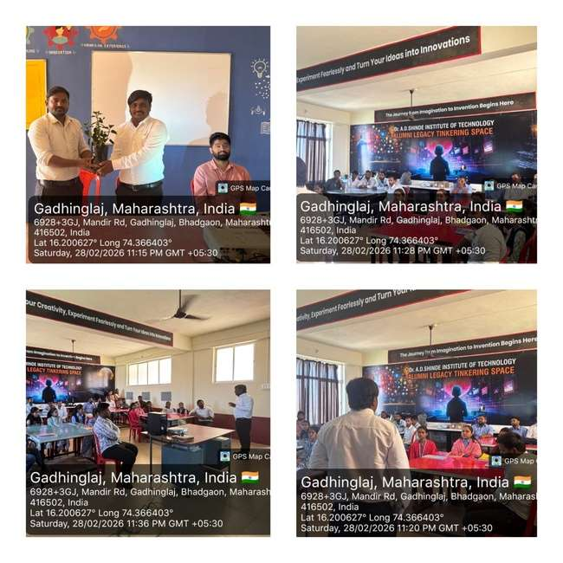

- Visit
Construction Site Visit at “Water Treatment Plant” Kolhapur.

Name of Event: Visit at “Water Treatment Plant, Kolhapur”
Date of Event: 27 ^{th} February 2026
Event Coordinator: Mr. A. S. Kamble
Aim of the Program:
The aim of the visit was to provide students with practical exposure to the working process of a Water Treatment Plant. The program was organized to help students understand various stages involved in water treatment such as coagulation, sedimentation, filtration, and disinfection. The visit focused on enhancing students’ knowledge of water purification systems and bridging the gap between theoretical concepts of environmental engineering and their practical implementation in real-world projects.
Program Details:
• Date: February 27th , 2026
• Venue: Kolhapur
• Participants: FY, SY & TY students
• Co-ordinator: Deputy Engineer, MIDC Kolhapur
Conclusion:
Through the visit to the Water Treatment Plant, Kolhapur, students gained firsthand knowledge of the complete water treatment process and plant operations. They observed various treatment units and understood the importance of quality control, monitoring systems, and safety measures in ensuring safe and potable water supply. The visit strengthened their understanding of environmental engineering concepts and highlighted the importance of sustainable water management practices in civil engineering.
Acknowledgement:
The Department of Civil Engineering extends its sincere gratitude to the Deputy Engineer, MIDC Kolhapur, for providing detailed guidance and valuable insights into the functioning of the Water Treatment Plant. The technical explanations and practical demonstrations greatly enriched the students’ learning experience.
We also acknowledge the efforts of our Head of Department, Mr. A. S. Kamble, and faculty members for successfully organizing this educational visit and ensuring its smooth execution.

Experience Glimpses of Visit:

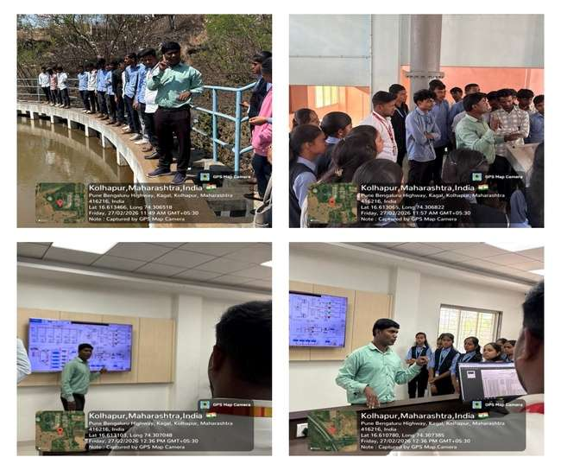

- Visit
Construction Site Visit at “Railway Station” Kolhapur.

Name of Event: Visit at “Railway Station” Kolhapur
Date of Event: 27th February 2026
Event Coordinator: Mr. A. S. Kamble
Aim of the Program:
The aim of the visit was to provide students with practical exposure to the components and functioning of railway tracks at Kolhapur Railway Station. The program was organized to help students understand the structural elements of railway tracks, including rails, sleepers, ballast, fastenings, and signaling systems, thereby bridging the gap between classroom learning and real-time railway engineering practices in civil engineering.

Program Details:
• Date: February 27th ,2026
• Venue: Kolhapur
• Participants: FY, SY & TY students
• Co-ordinator: Station Master, Kolhapur Railway Station.
Conclusion:
Through the visit to Kolhapur Railway Station, students gained firsthand knowledge of railway track components, track alignment, maintenance practices, and safety measures followed in railway operations. The visit enhanced their practical understanding of railway engineering concepts and infrastructure management. It also emphasized the importance of applying theoretical knowledge in real-life transportation engineering projects.
Acknowledgement:
The Department of Civil Engineering extends its sincere gratitude to the Station Master and staff of Kolhapur Railway Station for providing valuable insights into railway track components and operational practices. Their guidance and detailed explanations greatly enriched the students’ learning experience.
We also acknowledge the support and efforts of our faculty members and coordinators, whose guidance ensured the successful organization of this educational visit, making it an informative and practical learning experience for the students.

Experience Glimpses of Visit:

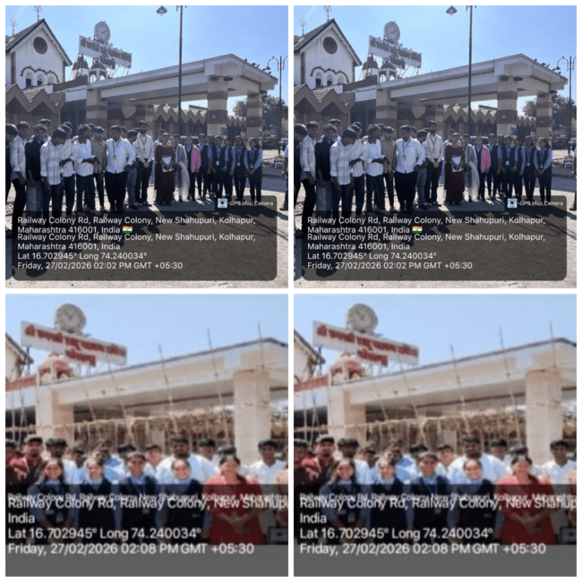

- Visit
Site Visit at “Rock Garden” Malvan.

Name of Event: Visit at “Rock Garden, Malvan.
Date of Event: 7 ^{th} March 2026
Event Coordinator: Mr. A. S. Kamble
Aim of the Program:

The aim of the visit was to provide students with practical exposure to landscape development, coastal protection structures, and recreational infrastructure at Rock Garden, Malvan. The program was organized to help students understand the planning, design, and construction of tourist and public utility structures developed near coastal areas.
The visit focused on enhancing students’ knowledge of site development, use of natural rock formations, pathways, retaining walls, seating arrangements, and coastal landscape architecture, thereby bridging the gap between theoretical concepts of civil engineering and their practical implementation.

Program Details:
• Date: March 7th , 2026
• Venue: Malvan
• Participants: FY, SY & TY students
•Co-ordinator: Chief Officer, Malvan Nagarparishad, Malvan Sindhudurg, Maharashtra 416606.

Conclusion:
Through the visit to Rock Garden, Malvan, students gained practical knowledge about coastal site development, landscaping techniques, and the construction of tourist infrastructure. They observed the use of natural rocks in landscape design, development of walkways, seating areas, protective railings, and safety measures provided for visitors.
The visit helped students understand the importance of sustainable development, environmental protection, and proper planning of recreational spaces in civil engineering projects. It also enhanced their awareness of how civil engineering contributes to tourism development and coastal infrastructure.

Acknowledgement:
The Department of Civil Engineering expresses its sincere gratitude to the officials of Malvan Nagarparishad for their valuable guidance and for providing important information regarding the development and maintenance of Rock Garden. Their explanations and interaction with students greatly enriched the learning experience.
We also acknowledge the efforts of our Head of Department, Mr. A. S. Kamble, and faculty members for successfully organizing this educational visit and ensuring its smooth execution.

Experience Glimpses of Visit:

