Dinkarrao K. Shinde Smarak Trust’s |  | 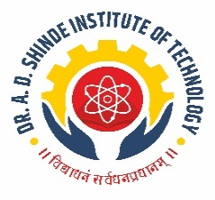
DR. A. D. SHINDE
INSTITUTE OF TECHNOLOGY
Approved by AICTE, Delhi, DTE Mumbai and Govt of Maharashtra. Affiliated to MSBTE, Mumbai.
DEPARTMENT OF CIVIL ENGINEERING
_____________________________________________________________________________________
MEGA-PROJECT DETAILS
THIRD YEAR - A. Y. (2025-26)
GROUP NO. | NAME OF PROJECT | NAME OF PROJECT GUIDE | PROJECT CATEGORY
01 | Structural Risk Analysis and Maintenance Prioritization of Building Using Risk Assessment Method (RAM) | Mr. A. S. KAMBLE | Application based
02 | Cost Estimation and Economic Analysis of Material Replacement in Building Construction | Ms. N. R. BHOI | Application based
03 | Study of Generation Rate and Economic Evaluation of Construction & Demolition Waste | MS.A.B. CHILAMI | Application based
04 | Non-Destructive Evaluation of Concrete Quality Using Rebound Hammer | Ms. S. R. WATANGI | Application based

