Dinkarrao K. Shinde Smarak Trust’s,  DR. A. D. SHINDE  INSTITUTE OF TECHNOLOGY  Approved by AICTE, Delhi, DTE Mumbai and Govt. of Maharashtra, Affiliated to MSBTE, Mumbai. | 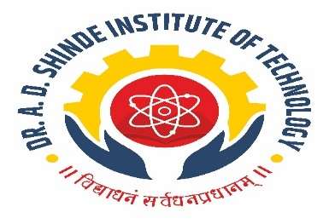

=========================================================================

DEPARTMENTAL TIME TABLE

Academic Year | 2025-26 | Program Name | Civil Engineering
Semester | CE5K | Class & Division | TYCE

TIME/DAY | MON |  | TUE | WED | THU | FRI | SAT
09.30 -10.30 | ETC |  | TOS | ENDS | ETC | TEST | SPI-PR
10.30-11.30 | TOS |  | WRE | WRE | LIB | LIB | SPI-PR
11.30-12:00 | LONG RECESS
12:00-01:00 | WRE |  | ETC | TOS | WRE | TEN-PR | SPI-PR
01:00-02:00 | SPI |  | TOS | TOS | TOS | TEN-PR | SPI-PR
02:00-02:15 | SHORT RECESS
02:15-03:15 | ENDS -PR | TEN |  | WRE -PR | TEN | LIB | SPI-PR
03:15-04:15 | ENDS -PR | TEN |  | WRE -PR | TEN | TEST | SPI-PR

Course Name | Course Code | Course Abbr. | Name of the Faculty
Water resource Engineering | 315314 | WRE | Mr. A. S. Kamble
Theory of Structure | 315313 | TOS | Mr. H. M. Patil
Road traffic Engineering | 315318 | TEN | Ma. A. B. Chilami
Emerging trends in civil Engineering | 315315 | ETC | Ms. N. R. Bhoi
Seminar and Project | 315003 | SPI | Mr. A. S. Kamble
Entrepreneurship Development and Startups | 315002 | ENDS | Mr. H. M. Patil

HOD ACADEMIC COORDINATOR PRINCIPAL

