Dinkarrao K. Shinde Smarak Trust’s,  DR. A. D. SHINDE  INSTITUTE OF TECHNOLOGY  Approved by AICTE, Delhi, DTE Mumbai and Govt. of Maharashtra, Affiliated to MSBTE, Mumbai. | 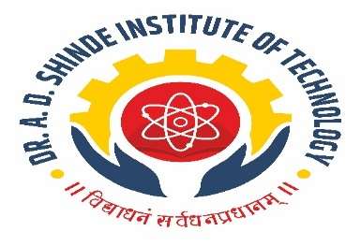
=========================================================================

DEPARTMENTAL TIME TABLE

Academic Year | 2025-26 | Program Name | Civil Engineering
Semester | CE3K | Class & Division | SYCE

TIME/DAY | MON |  | TUE | WED | THU | FRI | SAT
09.30 -10.30 | SOM |  | CTE | EIC | BDC | CMA | TEST
10.30-11.30 | HEN |  | ASU | HEN | HEN | TEST | SOM
11.30-12:00
12:00-01:00 | ASU |  | BDC | ASU | SOM | BDC(PR) | CMA(PR)
01:00-02:00 | SOM |  | CTE | LIB | CTE | BDC(PR) | CMA(PR)
02:00-02:15
02:15-03:15 | SOM(PR) | ASU(PR) |  | HEN (PR) | CTE(PR) | ASU(PR) | BDC(PR)
03:15-04:15

Course Name | Course Code | Course Abbr. | Name of the Faculty
Highway Engineering | 313323 | HEN | Ms. Akshata B. Chilami
Concrete Technology | 313322 | CTE | Mr. A. S. Kamble
Advance Surveying | 313321 | ASU | Ms. Neha R. Bhoi
Strength of Material | 313308 | SOM | Ms. Sheetal. R. Watangi.
Building Planning & Drawing with Auto CAD | 313009 | BDC | Mr. Harshvardhan M. Patil
Construction Management | 313010 | CMA | Mr. Harshvardhan M. Patil
Essence of Indian constitution | 313002 | EIC | Mrs. S. D. Chandure

HOD ACADEMIC COORDINATOR PRINCIPAL

