Dinkarrao K. Shinde Smarak Trust’s,  DR. A. D. SHINDE  INSTITUTE OF TECHNOLOGY  Approved by AICTE, Delhi, DTE Mumbai and Govt. of Maharashtra, Affiliated to MSBTE, Mumbai. | 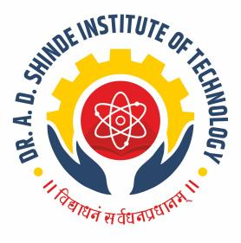
=========================================================================

DEPARTMENTAL TIME TABLE

Academic Year | 2025-26 | Program Name | CE
Semester | 6K | Class & Division | A

TIME/DAY | MON |  | TUE | WED | THU | FRI | SAT
09.30 -10.30 | DSR(ABC) PR |  | MRS(NRB) PR | MRS(NRB) | SWM(ASK) PR | CPE(ASK) PR | TEST
10.30-11.30 |  |  | MRS(NRB) PR | SWM(ASK) | SWM(ASK) PR | CPE(ASK) PR | LIB
11.30-12.00 | LONG RECESS
12.00-01.00 | SWM(ASK) |  | DSR(ABC) TU | MAN(SMI) | DSR(ABC) PR | DSR(ABC) | DSR(ABC)
01.00-02.00 | MRS(NRB) |  | DSR(ABC) TU | DSR(ABC) | DSR(ABC) PR | DSR(ABC) | CAA(HMP)
02.00-02.15 | SHORT RECESS
02.15-03.15 | MAN(SMI) | MAN(SMI) |  | CAA(HMP) PR | MRS(NRB) | CAA(HMP) | Mentor mentee
03.15-04.15 | CAA(HMP) | SWM(ASK) |  | CAA(HMP) PR | CAA(HMP) | MRS(NRB) | Mentor mentee

Course Name | Course Code | Course Abbr. | Name of the Faculty
MANAGEMENT | 315301 | MAN | MR. S. M. INGALE
CONTRACTS AND BILLING | 316307 | CAB | MR. H. M. PATIL
DESIGN OF RCC AND STEEL STRUCTURES | 316308 | DRS | MS. A. B. CHILAMI
MAINTENANCE AND REPAIRS OF STRUCTURES | 316309 | MRS | MS. N. R. BHOI
CAPSTONE PROJECT | 316004 | CPE | MR. A. S. KAMBALE
SOLID WASTE MANAGEMENT | 316312 | SWM | MR. A. S. KAMBALE

FACULTY HOD ACADEMIC COORDINATOR PRINCIPAL

