Dinkarrao K. Shinde Smarak Trust’s,  DR. A. D. SHINDE  INSTITUTE OF TECHNOLOGY  Approved by AICTE, Delhi, DTE Mumbai and Govt. of Maharashtra, Affiliated to MSBTE, Mumbai. | 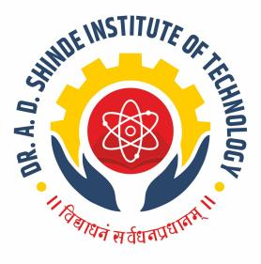
=========================================================================

DEPARTMENTAL TIME TABLE

Academic Year | 2025-26 | Program Name | CE
Semester | 4K | Class & Division | A

TIME/DAY | MON |  | TUE | WED | THU | FRI | SAT
09.30 -10.30 | WWE(ASK) |  | HYD(ABC) | HYD(ABC) | EES(HMP) | EES(HMP) | EES(HMP)
10.30-11.30 | GTE(NRB) |  | RBT(SGP) | ECV(SRW) | LIB | TEST | HYD(ABC)
11.30-12.00 | LONG RECESS
12.00-01.00 | RBT(SGP) |  | WWE(ASK) | GTE(NRB) | WWE(ASK) | WWE(ASK) | GTE(NRB)
01.00-02.00 | HYD(ABC) |  | ECV(SRW) | RBT(SGP) | ECV(SRW) | ECV(SRW) | RBT(SGP)
02.00-02.15 | SHORT RECESS
02.15-03.15 | ECV(SRW)-A  GTE(NRB)-B | GTE(NRB)-A  HYD(ABC)-B |  | WWE(ASK)-A  ECV(SGP)-B | ECV(SRW)-A  WWE(ASK)-B | HYD(ABC)-A  ECV(SGP)-B | Mentor mentee
03.15-04.15

GTE

Course Name | Course Code | Course Abbr. | Name of the Faculty
ENVIRONMENTAL EDUCATION AND SUSTAINABILITY | 314301 | EES | MR. H. M. PATIL
RAILWAY, BRIDGE AND TUNNEL ENGINEERING | 314312 | RBT | MRS. S. G. PATIL
HYDRAULICS | 314303 | HYD | MS. A. B. CHILAMI
ESTIMATING, COSTING AND VALUATION | 314313 | ECV | MS. S. R. WATANGI
WATER AND WASTEWATER ENGINEERING | 314314 | WWE | MR. A. S. KAMBALE
GEOTECHNICAL ENGINEERING | 314315 | GTE | MS. N. R. BHOI

FACULTY HOD ACADEMIC COORDINATOR PRINCIPAL

